SEASONS OF REFLECTION

2015 Daily Bible Reading Plan

Name: Starting Date: / / 2015

Fellowship Group: Finishing Date: / / 2015



Chinese Methodist Church

In Australia

The Board of Christian Education

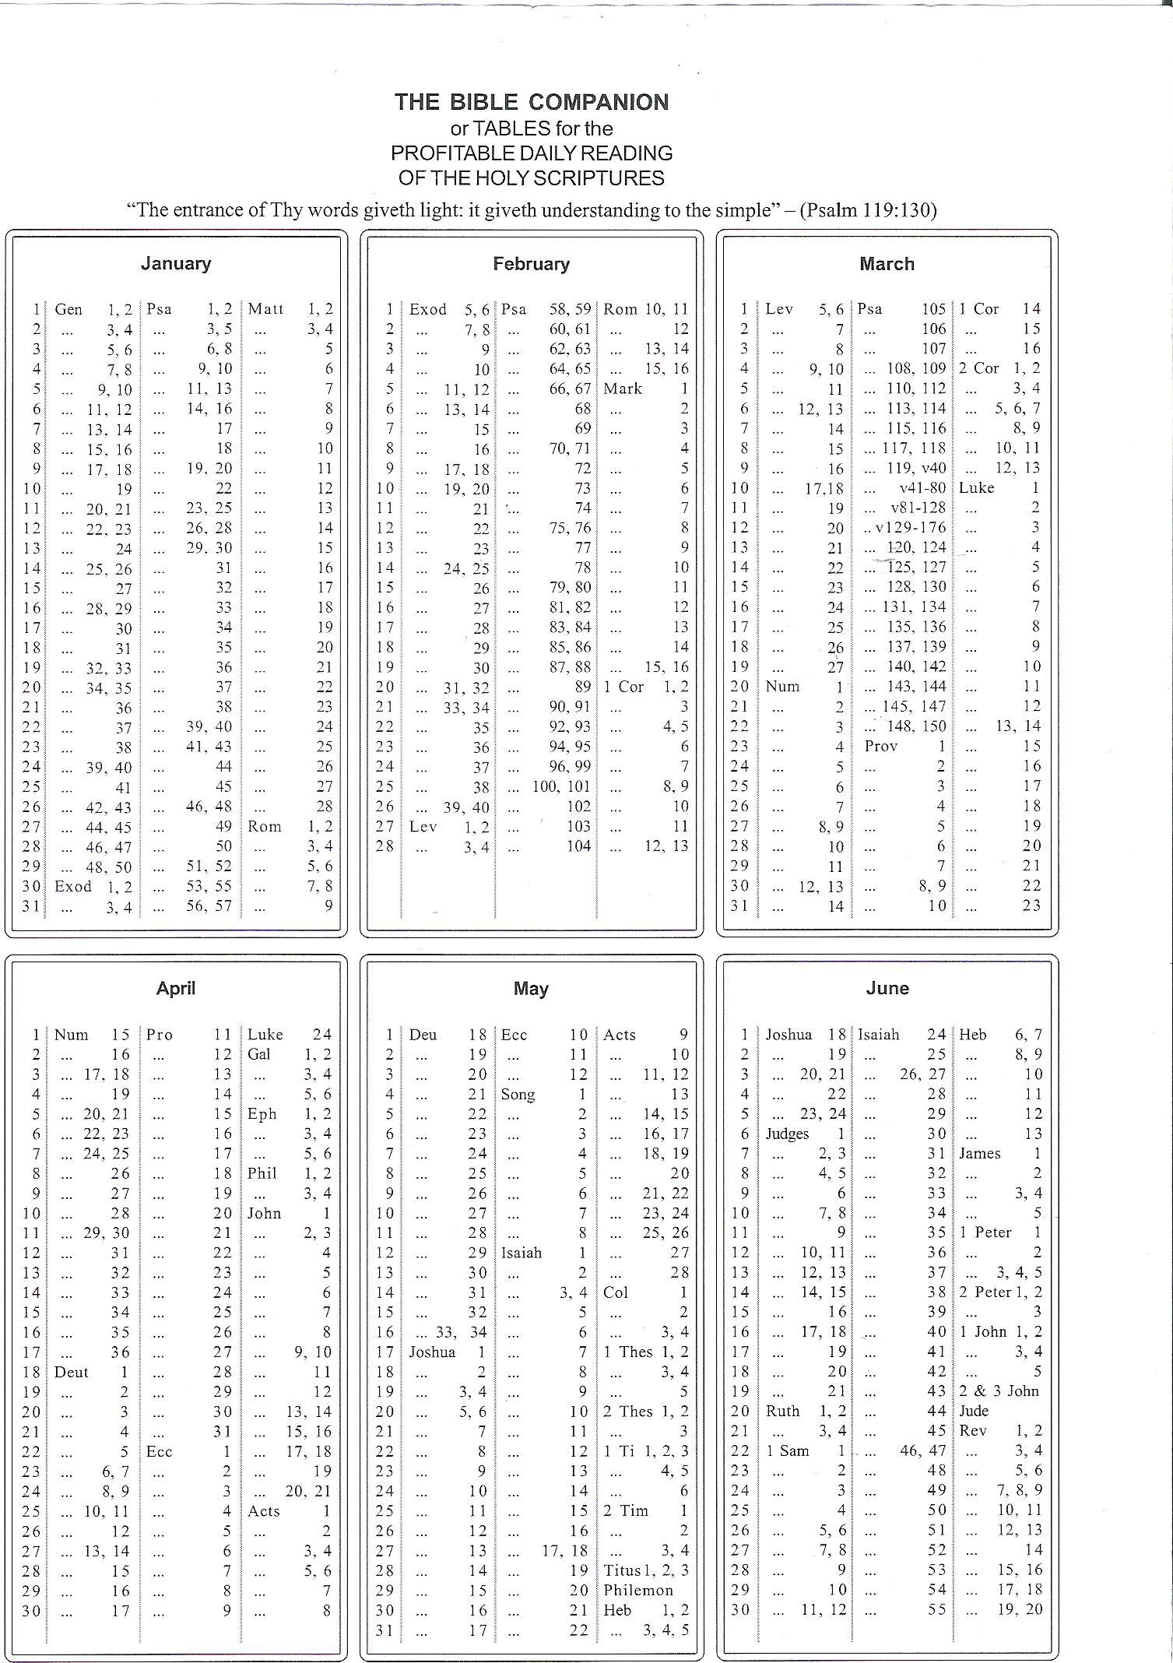

**Experience the insights and joy gained from reading the entire Bible.**

**Daily readings from the Old Testament, New Testament, Psalms and Proverbs**

**will guide you through God’s word in one year.**

